U F R E L I G I O N

NEWSLETTER


EVENTS
Department of Religion participated in the annual Majors and Minors Fair at the Honors Involvement Conference on Sunday, September 13th, sharing information about the department's programs, courses, and opportunities with students. See Page 2 for more details.
NEWS
Dr. Jeyoul Choi recently published an invited journal article in Religions 17(9). See Page 4 for more details.

Graduate student Rachaell Diaz recently won a travel grant. See Page 2 for more details.

Religion Alumna Dr. Victoria Machado of Rollins College will moderate the American Academy of Religion’s Publicly Engaged Scholarship in the Study of Religion Seminar on September 30th. See Page 3 for more details.


1

NEWS & EVENTS
- Graduate student Rachaell Diaz has been awarded an Annual Meeting Travel Grant from the American Academy of Religion (AAR). The highly competitive program provides travel support to a select group of members participating in the AAR Annual Meeting each November. Each year, only 15 grants are awarded, with recipients chosen by the AAR Annual Meeting Travel Grants Jury. This award recognizes both the quality of Diaz's scholarly work and her contributions to the field, while providing support for her participation in one of the discipline's premier professional conferences.

- The Department of Religion participated in the annual Majors and Minors Fair at the Honors Involvement Conference on September 13th. Hosted jointly by the Career Connections Center, Student Government, and CLAS Exploratory Advising, the event brought together academic departments, interdisciplinary programs, and faculty from across the University of Florida to showcase educational opportunities available to students.
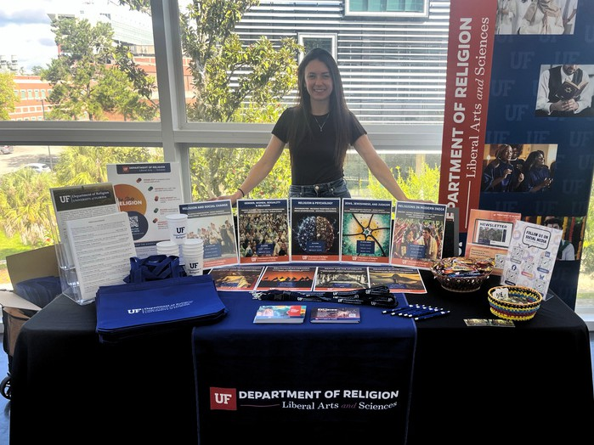

Ashley Tisher tabling at the Majors and Minors Fair
Throughout the event, students explored majors, minors, certificates, study abroad opportunities, internships, and other academic pathways while speaking directly with faculty and departmental representatives. The Department of Religion was pleased to connect with students, answer questions about its programs and courses, and share information about the many opportunities available through the study of religion at UF.

2

PRESENTATIONS

  - On June 8th, Dr. Robert Kawashima co-led a seminar with colleague Stephen Russell titled “The Biblical Covenant and Its Afterlife” for Leiden University’s Jewish Studies Network. During the seminar, Dr. Kawashima explored the significance of the Mosaic covenant within the wilderness narratives of Exodus through Deuteronomy, examining its function as a rite of passage and its role in shaping the religious identity and development of ancient Israel.

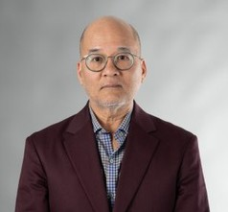

Dr. Robert Kawashima

  - Religion alum Dr. Victoria Machado of Rollins College will moderate the American Academy of Religion’s Publicly Engaged Scholarship in the Study of Religion Seminar on Wednesday, September 30, at 1:00 p.m. EDT. She will be joined by Sam Houston (Stetson University), Leela Prasad (Brown University), and Jason Sexton (UCLA). The online seminar, “Education and the Carceral Experience: Teaching and Learning Religious Studies,” is open to all interested participants.

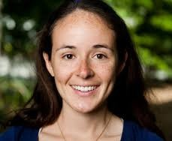

Dr. Victoria Machado

Drawing on current scholarship and teaching experiences, the seminar will examine the future of religious studies education in prison settings.
Panelists will share insights from their involvement in a range of prison-based educational programs and reflect on teaching and learning with diverse audiences, including currently and formerly incarcerated students, traditional university students, and members of the broader public. The conversation will also explore educational initiatives connected to abolitionist movements. Together, the speakers will contribute to ongoing discussions about the intersections of religion, incarceration, and education both within the Academy and beyond.

3

PUBLICATIONS
    - Dr. Jeyoul Choi, recently published an invited journal article in Religions 17(9) titled “The Grammar of Belonging: Asian Immigrant Religions and the Discipline of American Religious Pluralism.” The article appears in the special issue “Migration and Religion: Exploring the Impacts and Challenges of Cross-Cultural Integration.”

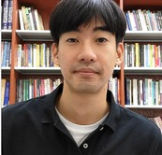

Dr. Jeyoul Choi

In the article, Dr. Choi examines how Asian immigrant communities become recognized and understood within an American religious landscape shaped by an Anglo-Protestant framework. This framework emphasizes belief, scripture, voluntary association, congregational organization, and the distinction between religion and culture. While these categories can facilitate recognition and belonging, they can also reshape Asian religious traditions through inherited Protestant, racial, colonial, and imperial frameworks.

The article connects scholarship on immigrant religion with postcolonial and decolonial critiques of the concept of “religion,” situating Asian American religious formation within both U.S. religious pluralism and broader transpacific histories of missionary activity, colonialism, Orientalism, and postcolonial classification.

    - Professor Bron Taylor was recently quoted in an Associated Press article titled “For These Midwest Farmers, Regenerative Agriculture Is About More Than Soil Health. It’s Spiritual” by Jessie Wardarski. Wardarski contacted Dr. Taylor while reporting the story and shared with him that his research had helped her better understand the forms of nature spirituality she was encountering throughout her reporting process. Building on themes discussed in Wardarski’s article, Taylor offered additional commentary and analysis in his Substack essay, “Nature Spirituality & Regenerative Agriculture.” Together, the two pieces explore the connections between regenerative agriculture, environmental values, and spiritual understandings of humanity’s relationship with the natural world.
4

STAY CONNECTED!
Follow Us On Social Media!



@ufreligion

University of Florida Religion Department

@ufreligion

University of Florida Religion

@ufreligion

Want To Contribute to the Newsletter?

If you have any information that you would like featured in the newsletter, please email Ashley Tisher (a.tisher@ufl.edu).

We look forward to hearing from you!

5

